PRESENTATION ON THE PARLIAMENTARY SYSTEM OF THE FEDERAL DEMOCRATIC REPUBLIC OF ETHIOPIA
—
Dagnachew BEFEKADU
Secretary General of the House of People’s Representatives (Ethiopia) and Habtamu NINI ABINO, Head of the Secretariat of the House of Federation (Ethiopia)
As we all know, Ethiopia is situated in the Horn of Africa bordered by Eritrea in the North, Sudan in the West, Kenya in the South, Somalia in the East and Djibouti in the North East. Its size is about 1.1m. square km with a population of over 73 million, according to the census of 2007. Addis Ababa is the capital city - a seat to many regional and international organizations.
Ethiopia is one of the oldest countries in the world and Africa’s third-most populous nation. It has also yielded some of humanity’s oldest traces, making the area a primary factor in the origin and developmental history of humanity, with recent studies -“Lucy” is a case in point.
The country is famous for its Olympic specially distance runners, rock-hewn churches and as the origin of the coffee bean. Ethiopia is home for both Christian and Muslim believers since earliest days, where both co-exist in peace and harmony. It’s also a home to other believers as well.
It became a member of the League of Nations in 1923, and one of the fifty-one original members of the United Nations (UN).
The headquarters of United Nations Economic Commission for Africa (UNECA) is in Addis Ababa, as is the headquarters of the Africa Union (formally the organization of African Unity), of which Ethiopia was the principal founders.
Addis Ababa, as a capital city all the Ethiopian, ethnic groups are represented in it due to its position as capital of the country. This Ethnic blend gives the city diverse of culture making the capital even more attractive. The major ethnic groups and the smaller ones live side by side in harmony and peace. The city is fully urban containing 22% of all urban dwellers in Ethiopia. Its population is around 3 million out of which the number of women is slightly more.
Climate wise, the city possesses a complex mix of highland climate zones, with temperature differences of up to 10ºc, depending on elevation and prevailing wind patterns. The high elevation moderates temperatures year-round, the city’s position near the equator means that temperatures are very constant from month to month.

Parliamentary system of the FDRE
As IPU is the international association of Parliaments of sovereign states, Ethiopia has been one of these member countries since 1962. The Union being the focal point for worldwide parliamentary dialogue that works for peace and co-operation among peoples and for the firm establishment of representative democracy, the Ethiopian Parliament, as a member shares the responsibilities of the Union in fostering contacts, co-ordination, and the exchange of experience among parliaments and parliamentarians of all countries; in contributing to the defense and promotion of human rights which is an essential factor of parliamentary democracy and development.
In Ethiopia the historical development of a parliamentary democracy has passed through three different types since its establishment in 1931. These are:
- The Parliament under Emperor Haile Selasise I.
- The National Assembly (Shengo) of the Military regime and
- The Ethiopian Parliament.
The Parliaments during the Emperor and the Military regime had a unitary form of parliament. Therefore, the idea of parliamentary democracy was at its rudimentary stage.
The present Federal Parliament came into being after the force led by the Ethiopian Peoples’ Revolutionary Democratic Front (EPRDF) overthrew the Military regime in May 1991, and set up the Transitional Government.
Then a Constitution that established a parliamentary system of Government came in to full force as of 21st August 1995. It created two Houses, namely, the House of Peoples’ Representative and the House of Federation. The Houses have their distinct and common roles to play, as a bicameral form of parliament.
The Peoples elect members of the House of Peoples’ Representative, whose seat number are 547, for a term of five years based on universal suffrage and by direct, free and fair elections held by secret ballot as stipulated in the constitution. The House of Federation on the other hand, having 120 seats, elected directly or indirectly by the Regional State Councils. The term of House is similarly five years.
The governance framework of the HoPR is:

  - The Assembly
  - Business advisory committee
  - The Speaker
  - Six Party Whips
  - Coordinating Committee
  - 13 Standing committees
  - Secretariat of the House

B. The House of Federation
Ethiopia, a home to more than 80 different nations, nationalities, and peoples; has the federal system that accommodates diversity. So, it has been federated into nine regional states with self-government. Pursuant to Article 62 of the Constitution, the main responsibilities of the House of Federation are: 1) Constitutional interpretation, 2) Conflict and dispute settlement and 3) Determine the division of revenues and subsidies that the Federal Government provide to the states.

The Secretariats of the two Houses
The increase in the number of opposition parties and their members, especially in this third term, has made the House prepare and implement rules of procedures and members code of conduct, which has brought significant influence on the service delivery. Although various changes have been made on the structural arrangements and working systems, significant improvement could not be brought.
Lately a study has been made in both secretariats using Business Process Reengineering (BPR) and the result has brought significant change on their structures, the number and qualification of the staffs, using IT, and so on. As a result, fundamental changes have been made to enable both secretariats to give quality and timely services that can ultimately enable the Houses to accomplish their purposes.”

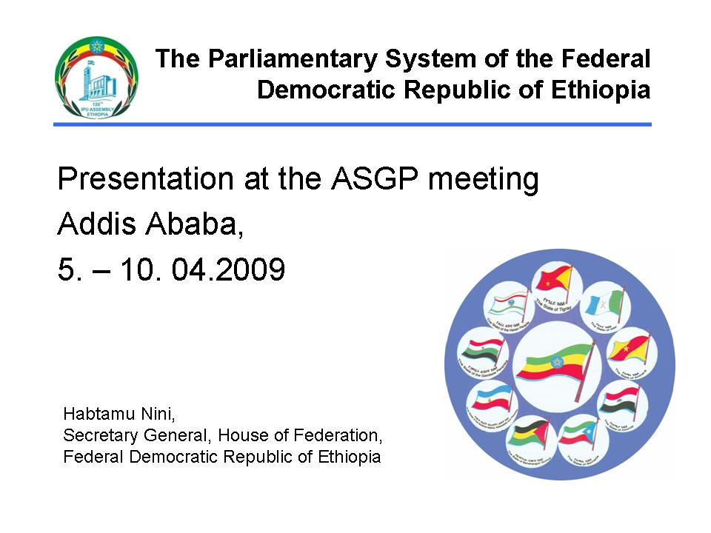
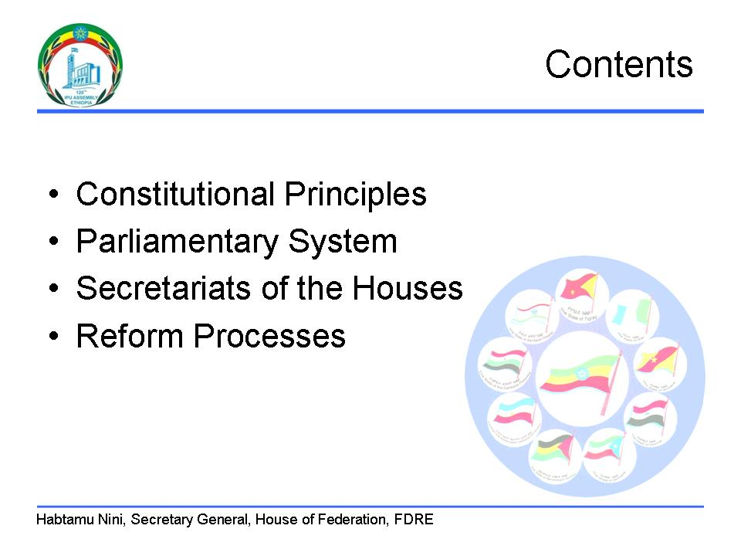
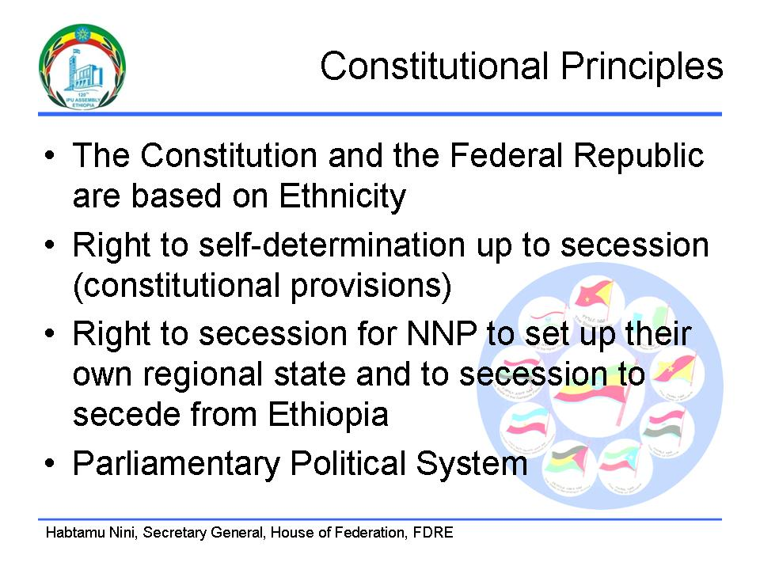

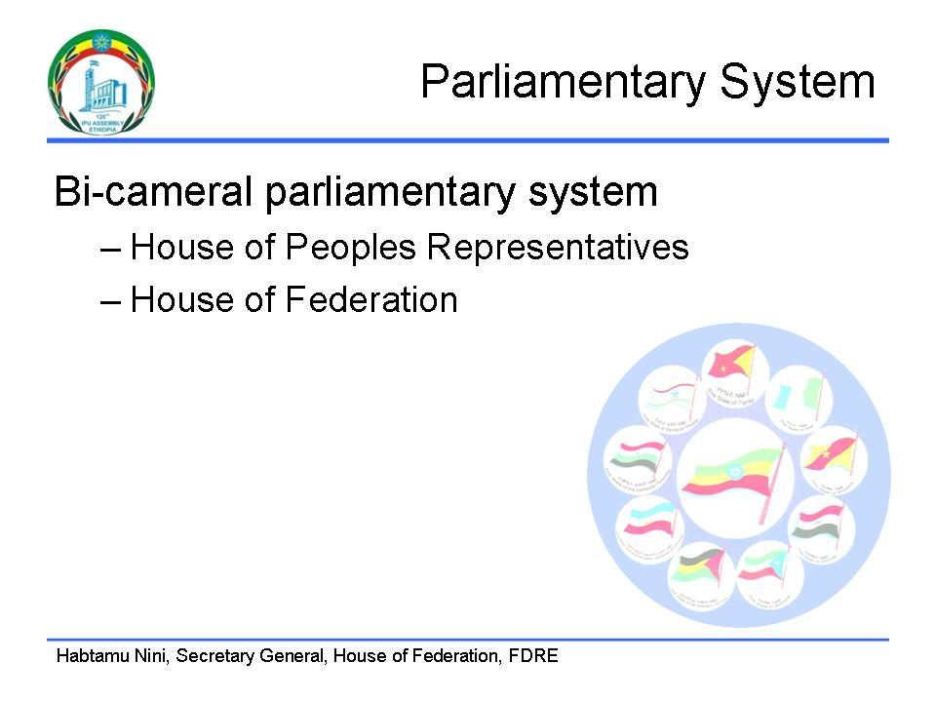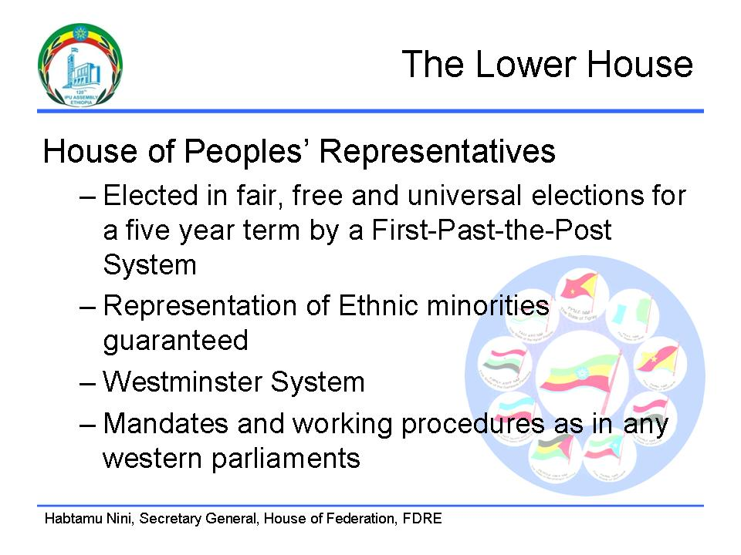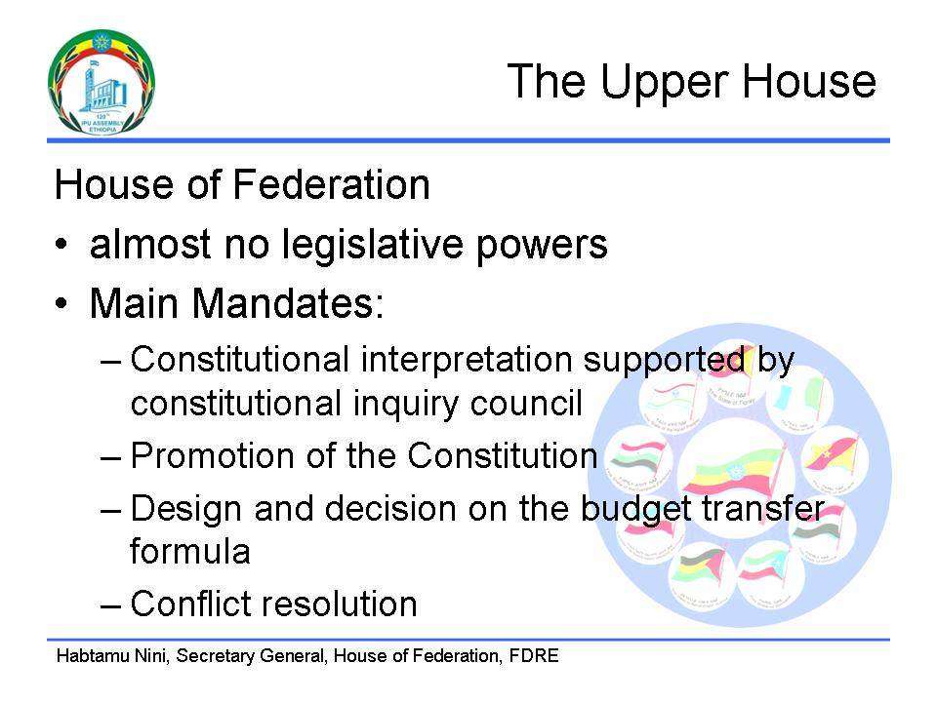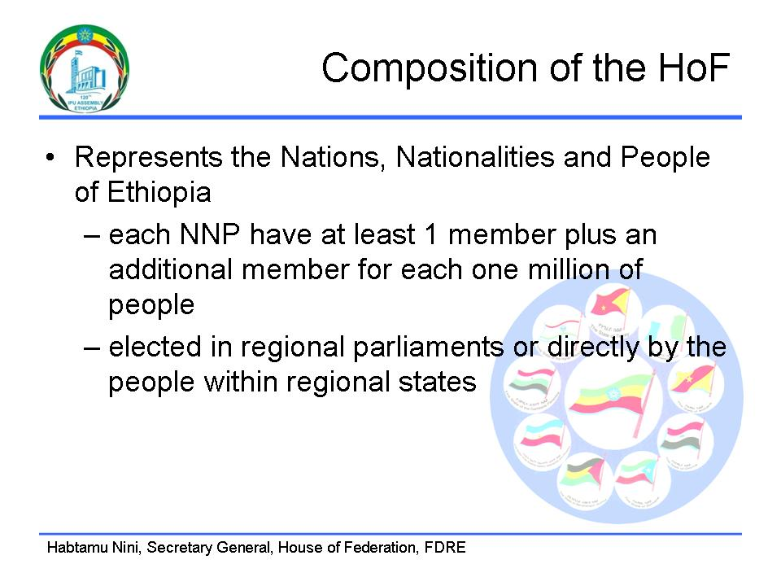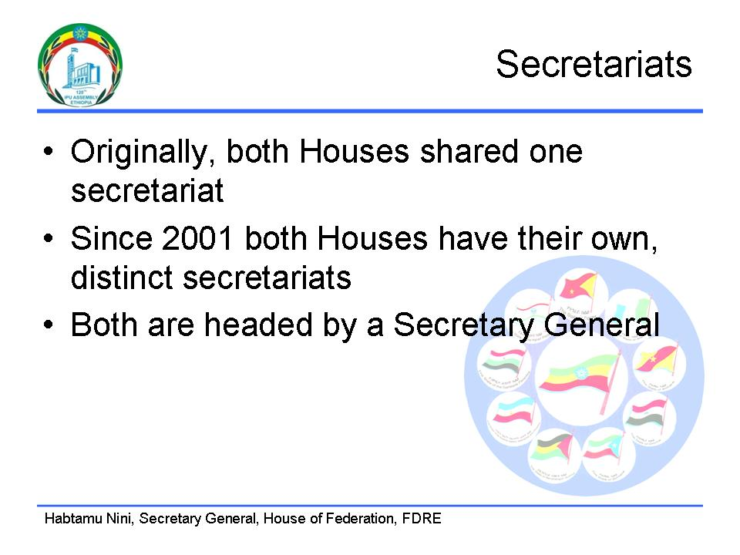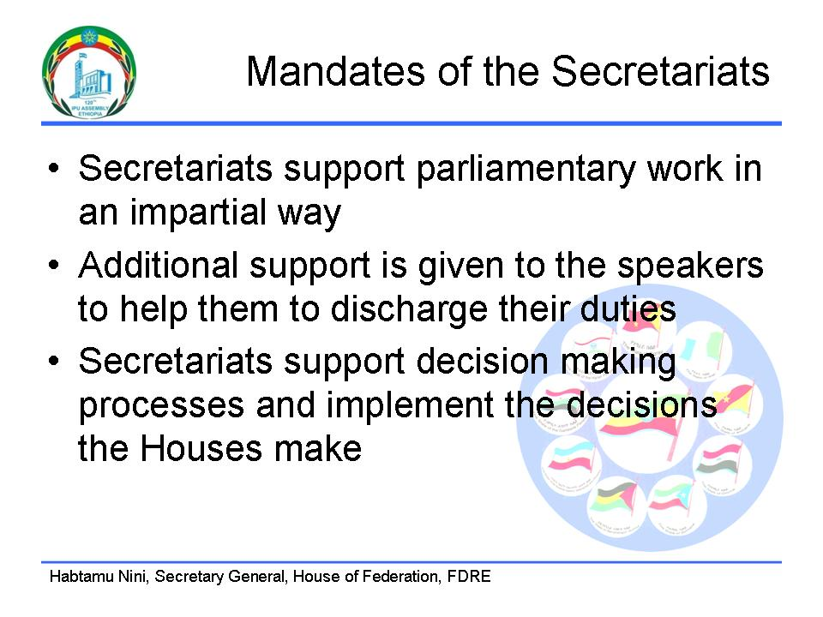

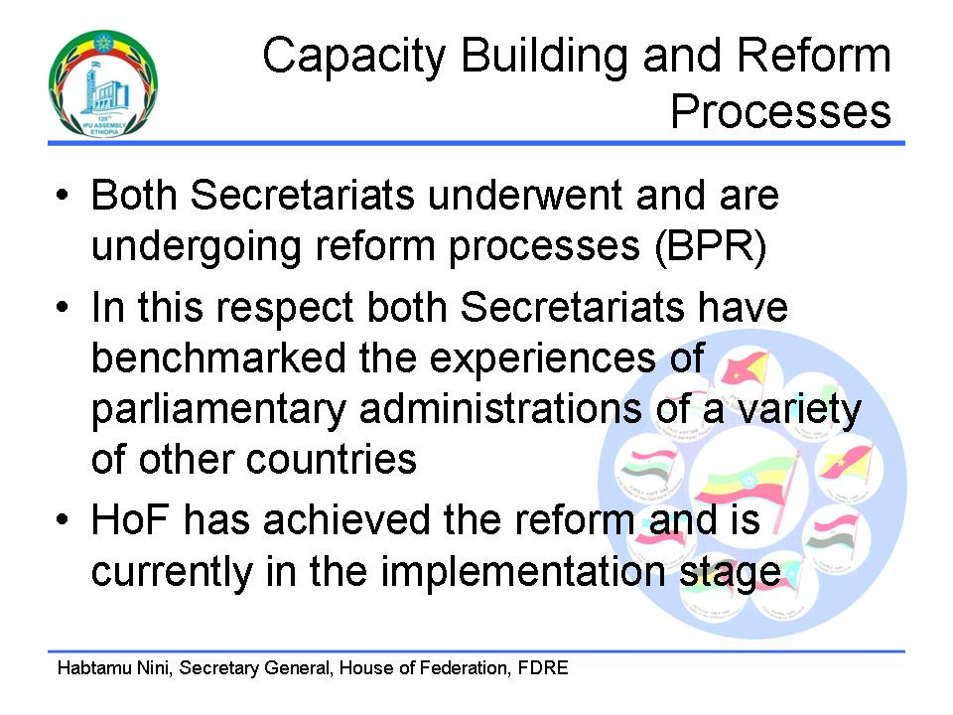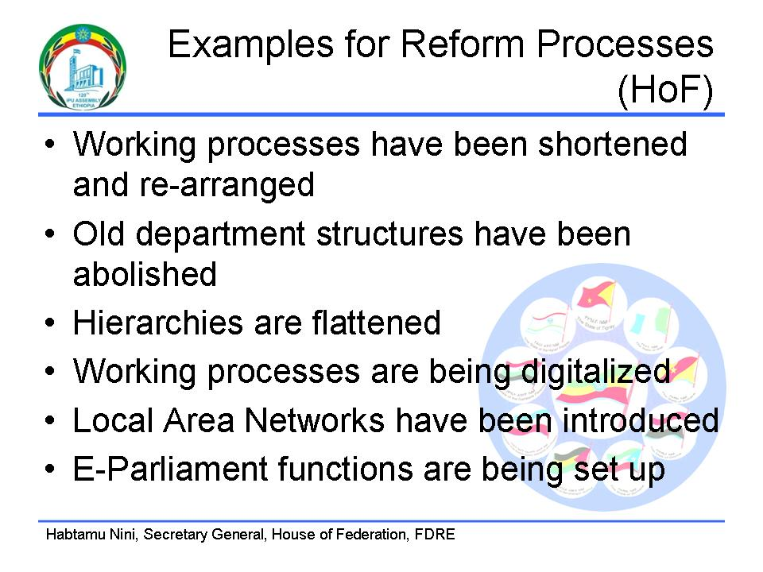

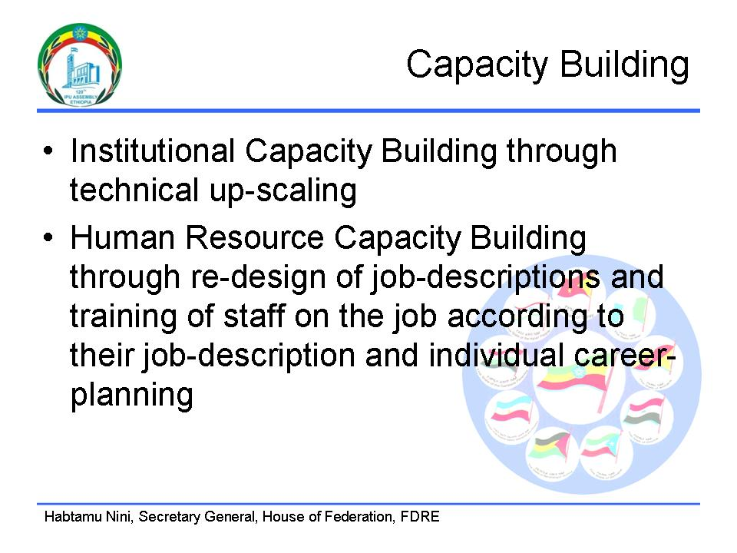


Mr Xavier ROQUES (France) asked what kind of parliamentary and constitutional structures existed in each of the nine states of Ethiopia.

Mr Manuel ALBA NAVARRO (Spain) asked about the nature of the legislative process, and whether more could be said about the right to secession.

Mr Moussa MOUTARI (Niger) asked about the size of the opposition in the two Chambers, and about the representation of minorities.

Mr Baye Niass CISSÉ (Senegal) asked about how members of the House of Federation were elected, whether directly or indirectly. He also asked how the right to secession could be exercised.

Mrs Maria Valeria AGOSTINI (Italy) asked about the role of the House of Federation in controlling the budget, and about the kind of conflict-resolution role it played.

Mr Christoph LANZ (Switzerland) asked for information about the secretariats of the two Chambers.

Dr Hafnaoui AMRANI, President asked whether MPs had played a role in the restructuring of the administration or whether it was an entirely internal administrative matter.

Mr Habtamu NINI ABINO replied that each of the nine regions had its own constitution, in line with the federal constitution, and its own representative councils. Minority representation referred to the various recognised minorities as described in the Ethiopian constitution. There were seats reserved in the House of Federation even for minorities the population size of which would not normally justify such representation. Election of representatives of nationalities was either direct by members of those nationalities, or indirect, through regional councils, depending on the regional constitution. The right to secession was a guarantee. To secede from the federation, a regional council had to take a majority decision in this direction; this would be followed by a referendum within three years, organised by the federal government. There were then legal and administrative steps that needed to be completed to establish secession, such as a division of assets. The House of Federation had a role in resolving border conflicts between regions.

Mr Dagnachew BEFEKADU replied that during the first two terms following the fall of the Communist government, the House of People’s Representatives was dominated by the governing parties. Now however, in the third term, more than one third of seats were occupied by opposition parties. Opposition members took part in the Business Advisory Committee and in Standing Committees. The chairperson of the Public Accounts Committee was from an opposition party, and many deputy chairpersons were drawn from the opposition. On the question of staffing, before 2001, all services in both Houses had been delivered from a single secretariat. Before business process engineering, the House of People’s Representatives had more than 600 largely non-professional staff. This had been reduced to 410, with more than 80 in the House of Federation. There had been many steps before business process engineering was undertaken. Various Members of Parliament had been involved, including the Speakers of both Houses and the Business Advisory Committee.

