ELECTION OF A SPEAKER
—
General debate moderated by Marc BOSC
Vice-President of the ASGP, Deputy Clerk of the House of Commons (Canada)

On the occasion of the opening of a new Parliament, the first scheduled item of business is the election of a Speaker.

MEMBER PRESIDING OVER THE ELECTION

The election is presided over by the Member with the longest period of uninterrupted service who is neither a Minister of the Crown, nor the holder of any office within the House. This Member is vested with all of the powers of the Chair, save that he or she retains the right to vote in the ensuing election, and is unable to cast a deciding vote in the event of an equality of votes being cast for two of the candidates. The Mace (symbol of the authority of the House) rests on a cushion on the floor beneath the table until such time as a new Speaker is elected.
Before proceeding with the election, the Member presiding will call upon any candidate for the office of Speaker to address the House for not more than five minutes; when no further candidate rises to speak, the Member presiding will leave the Chair for one hour after which Members will proceed to the election of a Speaker.
No debate may take place during the election, and the Member presiding shall not be permitted to entertain any question of privilege; no motion for adjournment nor any other motion shall be accepted while the election is proceeding and the House shall continue to sit, if necessary, beyond its ordinary hour of daily adjournment.

CANDIDATES

All Members of the House, except for Ministers of the Crown and Party Leaders, are automatically considered candidates for the position of Speaker. Any Member who does not wish to have his or her name appear on the list of candidates must so inform the Clerk of the House in writing by no later than 6:00 p.m. on the day before the election is to take place.

THE VOTING PROCEDURE

The election is conducted by secret ballot. A ballot box is placed at the foot of the Table and voting booths are placed on either side of the Table. The Member presiding announces that an alphabetical list of Members who may not be elected Speaker, either because they have notified the Clerk of their wish not to be considered for election, or because they are ineligible by virtue of being a Minister of the Crown or a Party Leader, is available at the Table, and that an alphabetical list of Members who are eligible to the Office of Speaker is available in each voting booth. Both lists are also distributed to Members at their desks.
The voting begins when the Member presiding asks those Members who wish to cast their ballot to leave their desks by way of the curtains, to proceed along the corridors in the direction of the Chair and to come to the Table through the door to the left of the Chair if the Member sits on the Speaker’s left, or through the door to the right if the Member sits on the Speaker’s right. At these doors, Members have their names recorded and are issued a ballot paper by one of the Table Officers. Members must enter through the correct door, as the Table Officers have only a partial list of Members’ names at each entrance, depending on which side of the House Members are seated. From there, each Member proceeds to the appropriate voting booth installed at the Table, print on the ballot paper the first and last name of his or her choice, deposit it in the ballot box at the foot of the Table and then leave the area around the Table to ensure the confidentiality of the voting procedure for other Members.
When the Member presiding is satisfied that all Members wishing to vote have done so, the Clerk and the Table Officers withdraw from the Chamber and proceed to count the ballots. The Member presiding then signifies that the sitting is temporarily suspended while the counting of the ballots takes place.

RESULTS OF THE FIRST BALLOT

Once the Clerk is satisfied with the accuracy of the count, she destroys all ballot papers and related records. The Standing Orders enjoin the Clerk not to divulge in any way the number of ballots cast for any candidate. When the count is complete, the Member presiding orders the bells to be rung for five minutes and then calls the House to order.
If any Member has received a majority of the votes cast, the Clerk gives the Member presiding the name of the successful candidate, which is then announced from the Chair. Having invited the Speaker-elect to take the Chair, the Member presiding steps down. The Speaker-elect, standing on the upper step of the dais, thanks the Members and assumes the Chair. The Sergeant-at-Arms takes the Mace from under the Table and places it on the Table, signifying that now, with the Speaker in the Chair, the House is properly constituted.

THE SECOND BALLOT

If, however, no Member has received a majority of the votes cast on the first ballot, the Clerk gives the Member presiding an alphabetical list of those Members who can be considered on the second ballot. The name or names of the Member or Members who have received the least number of votes on the previous ballot, and the names of the Members who have received five percent or less of the total votes cast are dropped from the list. The Member presiding indicates that a second ballot is necessary and announces the names of the candidates on the second ballot. He or she also asks any Member whose name has been so announced and who does not wish to be further considered to state the reason, after which the Clerk is instructed to remove from the list of eligible candidates the names of Members who have withdrawn.
When an alphabetical list of Members eligible to be considered on the second ballot is available in each voting booth, the Member presiding asks those Members who wish to vote to leave their desks and proceed to the Table in the same manner as was done on the first ballot.

RESULTS OF THE SECOND BALLOT — ADDITIONAL BALLOTS

The voting procedure for the second ballot is the same as for the first, except that for this and any subsequent ballots, ballot papers are of different colours. When the Member presiding is satisfied that all Members wishing to vote have done so, he or she instructs the Clerk to proceed with the count of the second ballot. When the count is complete, the Clerk again proceeds to destroy all the ballot papers and related records. This being done, the Member presiding calls the House to order and announces the name of the successful candidate (in which case the subsequent procedure is the same as if a candidate had been successful on the first ballot), or announces that a third ballot is necessary (in which case the names of the candidates eligible for the third ballot are read). The Member presiding also asks any Member whose name has been announced and who does not wish to be further considered to so indicate, although on this third and any subsequent ballots which may be necessary, he or she does not ask them to state their reasons for withdrawal. The Clerk then removes from the list of candidates eligible for the third ballot the names of Members who have withdrawn.
The voting procedure for the third ballot is the same as for the second, and balloting continues until a candidate has received a majority of the votes cast.
On the occasion of the opening of a new Parliament, the first scheduled item of business is the election of a Speaker.

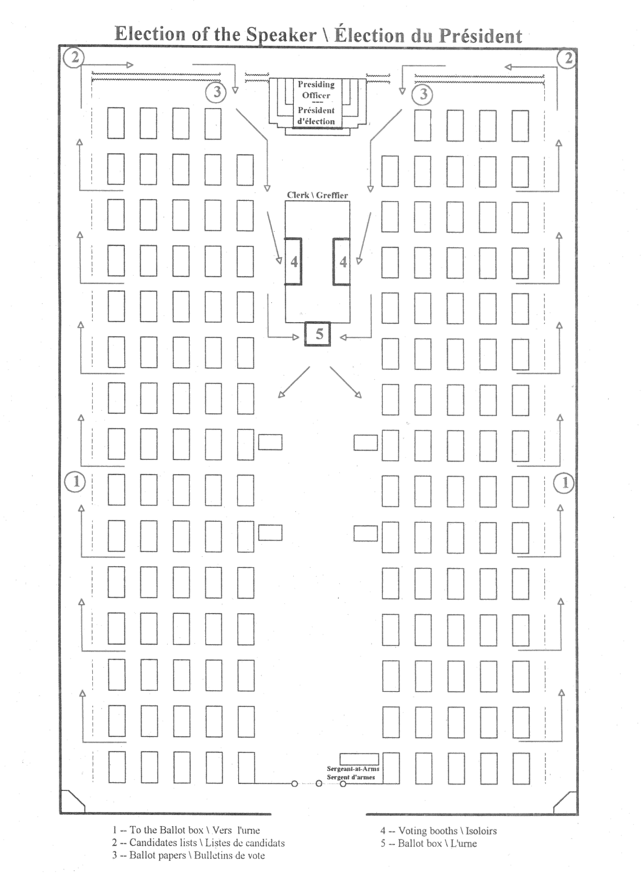

Ms Maria Valeria AGOSTINI (Italy) presented the following contribution:
Before talking about how a President of the Assembly is elected, I should need to point out from the start that the Italian Parliament consists of two Houses which, under the Constitution, have totally equal powers: both Houses pass bills and vote the confidence in a new Government, as per Article 94 of the Constitution. This arrangement is known in Italy as bicameralismo perfetto, or perfect bicameralism.
This said, I will now illustrate how the Presiding Officer of each House is elected, and then I will briefly touch upon their responsibilities.
First of all, a few words should be spent on the Interim Bureaus.
The first sitting of a new Senate after a general election is chaired by the oldest member, with the youngest members acting as Secretaries, or Tellers.
The first sitting of the Chamber of Deputies, instead, is presided over by the senior most Vice President of the previous term, by election, if he or she is still a member. Otherwise, a Vice President from older Parliaments is considered.
As you can see, the Rules of the Chamber attach more importance to the experience gathered in previous Parliaments rather than age, as is the case with the Senate. It is worth noting, though, that the Senate includes among its members a small group of life-appointees, which means that the interim chair is usually held by a rather old senator.
The interim Presiding Officer, however, keeps the chair only until a new President is elected.
Also the election of a President follows different rules in the Senate and the Chamber.
In the Senate, the candidate who gains an absolute majority of the members of the Senate in the first two ballots is elected. If such majority is not attained, a third ballot is held on the following day, in which the absolute majority of votes cast shall be sufficient. If again no candidate reaches that threshold, a fourth ballot is held between the two candidates who have obtained the most votes in the third ballot.
To elect the President of the Chamber, the majorities required are two-thirds of members in the first ballot, two-thirds of votes cast in the second ballot and an absolute majority of votes cast in the third ballot and thereafter. Ballots continue until such threshold is reached by a candidate.
What are the reasons at the root of these differences in the election of a President?
The ample majority needed to elect a President in the Chamber has been construed to make it imperative for a Presidential candidate to obtain a support broader than that required to vote the confidence in the Government.
In the Senate, instead, recourse to a run-off vote on the fourth ballot is intended to spell out the risk of a long vacancy at the helm of the Upper House, which might be dangerous in that the President of the Senate is the second highest ranking officer in the country and acts as Head of State when the President of the Republic is incapacitated.
The ways in which the Presiding Officers are elected is therefore closely linked with the institutional roles vested into them by the Italian Constitution.
I cannot dwell at length here on the responsibilities of the two Presiding Officers, which might well be the object of a wholly different debate and exchange of experiences in the various arrangements.
Suffice it to say here that the rules governing the election of a President are meant to lead to the choice of an officer who is a guardian of fair implementation of the Rules of procedure and an impartial guarantor of the rights of the opposition. The ample majorities required to elect such figures bear testimony of this, although such requirement, as I said before, must be reconciled in the Senate with the need to avert a constitutional vacancy if the third ballot is unsuccessful.



Mr Austin ZVOMA (Zimbabwe) asked what the rationale was for considering all eligible members as candidates, as well as for the destruction of ballot papers and for not allowing candidates to observe the count. He noted similarities and differences in the system in Zimbabwe. The Clerk of the Parliament was responsible for presiding over the election of the Speaker of the House of Assembly and the President of the Senate. There was a nomination process: only those nominated and seconded were included on the ballot papers. Voting booths and ballot boxes were provided in the Chamber. Counting was observed, and results were announced in the Chamber.

Mr Abdelhamid Badis BELKAS (Algeria) was particularly interested by the fact that only the clerks knew the results of the elections. What was the procedure then for contesting these results?

Mr Mohamed Kamal MANSURA (South Africa) asked how the oath was administered to swear the clerks to secrecy. In South Africa the election was presided over by the Chief Justice. Ballots were sealed and kept for a year, before being destroyed. They could only be opened on an order of the court.

Mr René KOTO SOUNON (Benin) was also concerned by the destruction of ballot papers. He asked why the ballot papers were not counted in front of the Members. In the Benin system, there was a temporary Bureau of the Ages, made up of the oldest and youngest of Members. The election of the Speaker took place at the same time as the election of other members of the bureau.

Mr Ibrahim MOHAMED IBRAHIM (Sudan) said that in his country the oldest Member presided over proceedings at the opening of a Parliament. Any Member could nominate any other for the Speakership. Those nominated were prohibited from advancing their own candidacy, either themselves or through other Members.

Dr V.K. AGNIHOTRI (India) said that the procedure in India was similar to that in Zimbabwe. He asked for clarification on three points: How many candidates normally were there? Why was it important that the Member presiding should have unbroken service? What happened if Members who voted in the first ballot abstained from voting in subsequent ballots, or if some who abstained in the first ballot voted in subsequent ballots?

Mr Constantin TSHISUAKA KABANDA (Democratic Republic of the Congo) said that in his country, the Secretary General convened the plenary sitting after elections and established a provisional bureau made up of the oldest and youngest Members. Recently, the Bureau of the National Assembly had been forced to resign en masse by the political groups, a situation not provided for in the Constitution. He wondered what solutions had been found in other countries for this kind of predicament. In Congo, the situation had arisen during a recess; but the Speaker insisted on waiting until the plenary was again in session to tender his resignation. He asked the plenary to agree that the outgoing bureau should deal with interim issues. There was opposition to this proposal, and a technical bureau was established instead.

Mrs Jacqueline BIESHEUVEL-VERMEIJDEN (Netherlands) said that in her country, until 2002, there had been no elections for the Speakership. A name was simply proposed by the largest party group. The current procedure was that at the end of a Parliament, a profile was devised for the Speaker: this was readopted by the new Parliament and candidacies were invited. The former Speaker served as acting Speaker, or, if no former Speaker had been re-elected, a former Deputy Speaker. Counting of votes was conducted by four Members selected by the interim Speaker. There was a system of multiple ballots: normally there were three. There was a debate before voting, which required a full day. She was not sure that the current system of free elections was better than the system in place before 2002. The position of the Speaker had become more political than before.

Mrs Maria Valeria AGOSTINI (Italy) said that in the House of Representatives, a candidate needed an absolute majority of Members to be elected as Speaker, not a majority of the votes cast. Was this different from the Canadian system? In the Italian Senate, run-off votes took place from the third ballot. This was because of the need to avoid a risk of a long vacancy, as the Senate President needed to be available to replace the President of the Republic in extremis.

Dr Ulrich SCHÖLER (Germany) mentioned two ways in which the German system differed from the Canadian. After an election, the oldest Member presided. More importantly, there was an unwritten rule that the biggest political group in Parliament had the right to present the candidate for the Speakership. There was the opportunity for a vote, but there had never been a situation in which a majority had not been achieved. Following a vote, the Speaker could not be removed. He asked if under the Canadian system, a Speaker could be removed during a Parliament. Additionally, how many candidates were there normally?

Mrs Marie-Françoise PUCETTI (Gabon) said that officers of the bureau in Gabon were elected in the same way as in Congo and Benin. She asked if two candidates from the same party could stand for election as Speaker.

Mr Sosthène CYITATIRE (Rwanda) said that the Canadian system was similar to that in Rwanda, but there were some differences. In Rwanda, the whole Bureau was elected at the same time. Under Rwanda’s constitution, no party could take more than 50% of the seats in Parliament. The Speaker of the Assembly had to come from a different party from that of the President of the Republic, the Prime Minister, and the presiding officer of the Senate. Deputy Speakers had to come from other parties than the Speaker: they tended to be representatives of the smallest parties. At the opening of Parliament, the President of the Republic himself presided.

Dr José Pedro MONTERO (Uruguay) said that the Speaker in Uruguay was elected in a very different way from the Speaker in Canada. There was a different Speaker for each year of a five-year Parliament: in three of the years the Speaker would come from the party of government, in the other two years from opposition parties.

Mrs Jacqy SHARPE (United Kingdom) said that in the House of Commons, the rules had changed recently. In 2000, 12 different MPs had put themselves forward for election as Speaker. Following criticism of the process, the Procedure Committee made recommendations which were accepted by the House in March 2001. The new procedure involved an exhaustive secret ballot. Candidates had to show willingness to stand, and acquire the signatures of at least 12 Members, three of whom had to be from parties other than their own. Each candidate had the opportunity to address the House, in an order chosen by lot. The last time a Speaker had been removed from office was in 1835.

Mr Christoph LANZ (Switzerland) suggested that the Clerks seemed to have a determining role in the future Speaker in Canada! In Switzerland, a provisional committee of MPs was created to count the results of ballots for the Speakership. Ballots were destroyed after they had been counted, but as MPs were involved in observing the count, there was an opportunity to raise questions before this happened. He asked if issues regarding the count in Canada had ever been raised.

Mr Mohamed TRAORÉ (Mali) said that the Malian experience was similar to that of other African countries. He noted a kind of ‘copycat’ behaviour, and thought it important to revisit procedures in the light of those of others. In Mali, there were inter-party negotiations about the composition of the bureau. He asked about the role of an elected Speaker compared with that of the Executive, and about the stability of national institutions. He mentioned events in Senegal and the Democratic Republic of Congo which suggested that the Executive had become involved in the conduct of the Speakership.

Mrs Fatou Banel SOW GUEYE (Senegal) asked how a contested election in Canada would be managed given the fact that ballot papers were destroyed. She suggested giving precedence to a consensual arrangement for electing a bureau.

Mr Marc BOSC (Canada), concluding the debate, said that the number of contributors underlined the importance of the issue, and of general debates as part of the Association’s work. The number of candidates in Canada had varied over time. It was easy to distinguish, however, between real and ‘accidental’ candidates, who declared themselves almost immediately. The number of real candidates had varied between 3 and 10. The first secret ballot for Speaker had taken 11 hours, but subsequently it had become much faster. The power of the clerks was peculiar to the Canadian context. In the 1980s when the procedure was established, there had been a long period of majority rule, with a name always being put forward by the majority party. The Procedure Committee had thought it important to empower private Members through a secret ballot, and the involvement of the clerks was designed to ensure absolute secrecy in the ballot, and no semblance of party interference. Apart from a few individual questions and comments, there had been no serious challenge to the elections. This was a mark of the status of the clerks in Canada as impartial servants of Parliament. The Clerk of the House was administered the oath by the Speaker on taking up office, and other clerks involved in the count had the oath administered to them by the Clerk of the House. The reason for keeping the results of ballots secret was so as not to influence the outcome of subsequent rounds. Members of Parliament in Canada were not controlled in any way: they were free not to vote if they chose. So to seek an absolute majority of Members rather than of votes cast could give unexpected power to Members wanting to boycott the process. To date, turnout had been very good. There was no Canadian counterpart to the bureau, so it was difficult for him to comment on this area. Unbroken service as a criterion for presiding over the first session was an arbitrary decision. The new Speaker was much more independent than under the old system in Canada because of the method of election. A Speaker could be removed under a motion of censure, but he was not aware that it had ever happened. A resignation would be the most likely outcome of such a motion. There were often several candidates from the same party. If any questions remained to be answered, he would be happy to do so afterwards.

